Regression with Boosted Decision Trees

[View all machine learning examples](https://www.mathworks.com/solutions/machine-learning/examples.html)

In this example we will explore a regression problem using the Boston House Prices dataset available from the UCI Machine Learning Repository.

Download Housing Prices

filename = 'housing.txt';

urlwrite('http://archive.ics.uci.edu/ml/machine-learning-databases/housing/housing.data',filename);

inputNames = {'CRIM','ZN','INDUS','CHAS','NOX','RM','AGE','DIS','RAD','TAX','PTRATIO','B','LSTAT'};

outputNames = {'MEDV'};

housingAttributes = [inputNames,outputNames];

Import Data

Once the file is saved, you can import data into MATLAB as a table using the [Import Tool](https://www.mathworks.com/help/matlab/import_export/import-data-interactively.html) with default options. Alternatively you can use the following code which can be auto generated from the Import Tool:

formatSpec = '%8f%7f%8f%3f%8f%8f%7f%8f%4f%7f%7f%7f%7f%f%[^\n\r]';

fileID = fopen(filename,'r');

dataArray = textscan(fileID, formatSpec, 'Delimiter', '', 'WhiteSpace', '', 'ReturnOnError', false);

fclose(fileID);

housing = table(dataArray{1:end-1}, 'VariableNames', {'VarName1','VarName2','VarName3','VarName4','VarName5','VarName6','VarName7','VarName8','VarName9',

'VarName10','VarName11','VarName12','VarName13','VarName14'});

% Delete the file and clear temporary variables

clearvars filename formatSpec fileID dataArray ans;

delete housing.txt

Read into a Table

housing.Properties.VariableNames = housingAttributes;

X = housing{:,inputNames};

y = housing{:,outputNames};

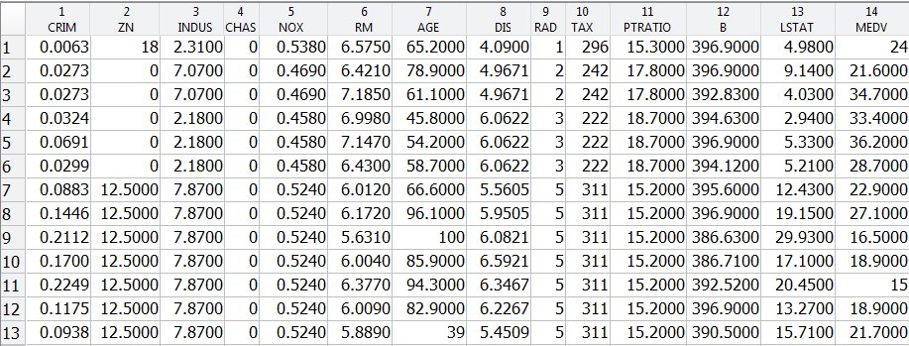

Train a Regression Tree Using the Housing Data

rng(5); % For reproducibility

% Set aside 90% of the data for training

cv = cvpartition(height(housing),'holdout',0.1);

t = RegressionTree.template('MinLeaf',5);

mdl = fitensemble(X(cv.training,:),y(cv.training,:),'LSBoost',500,t,...

'PredictorNames',inputNames,'ResponseName',outputNames{1},'LearnRate',0.01);

L = loss(mdl,X(cv.test,:),y(cv.test),'mode','ensemble');

fprintf('Mean-square testing error = %f\n',L);

Mean-square testing error = 7.056746

Plot Fit Against Training Data

figure(1);

% plot([y(cv.training), predict(mdl,X(cv.training,:))],'LineWidth',2);

plot(y(cv.training),'b','LineWidth',2), hold on

plot(predict(mdl,X(cv.training,:)),'r.-','LineWidth',1,'MarkerSize',15)

% Observe first hundred points, pan to view more

xlim([0 100])

legend({'Actual','Predicted'})

xlabel('Training Data point');

ylabel('Median house price');

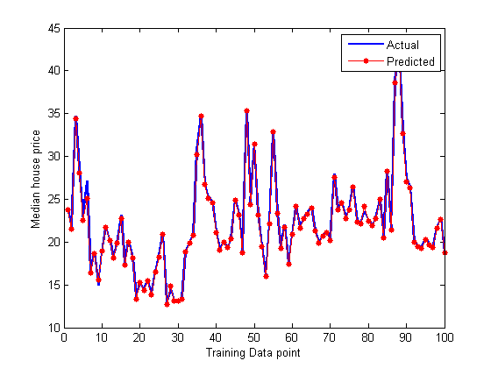

Plot Predictor Importance

Plot the predictors sorted on importance.

[predictorImportance,sortedIndex] = sort(mdl.predictorImportance);

figure(2);

barh(predictorImportance)

set(gca,'ytickLabel',inputNames(sortedIndex))

xlabel('Predictor Importance')

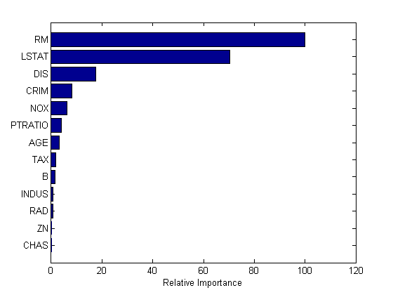

Plot Error

figure(3);

trainingLoss = resubLoss(mdl,'mode','cumulative');

testLoss = loss(mdl,X(cv.test,:),y(cv.test),'mode','cumulative');

plot(trainingLoss), hold on

plot(testLoss,'r')

legend({'Training Set Loss','Test Set Loss'})

xlabel('Number of trees');

ylabel('Mean Squared Error');

set(gcf,'Position',[249 634 1009 420])

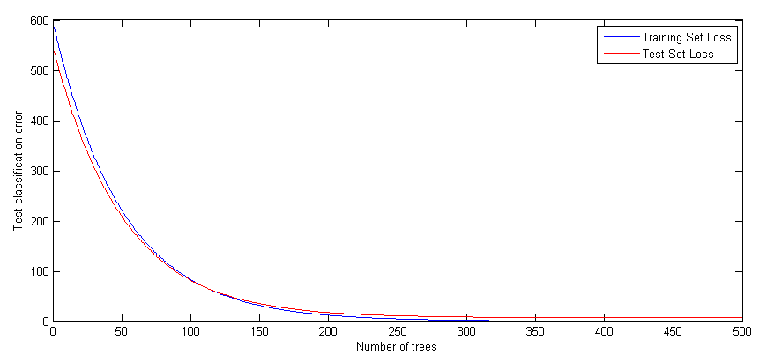

Regularize and Shrink the Ensemble

We may not need all 500 trees to get the full accuracy for the model. We can regularize the weights and shrink based on a regularization parameter

% Try two different regularization parameter values for lasso

mdl = regularize(mdl,'lambda',[0.001 0.1]);

disp('Number of Trees:')

disp(sum(mdl.Regularization.TrainedWeights > 0))

Number of Trees:

194 128

Shrink the ensemble using Lambda = 0.1

mdl = shrink(mdl,'weightcolumn',2);

disp('Number of Trees trained after shrinkage')

disp(mdl.NTrained)

Number of Trees trained after shrinkage

128

When datasets are large, using a fewer number of trees and fewer predictors based on predictor importance will result in fast computation and accurate results.

Reference and License

Example from [scikit-learn.org](http://scikit-learn.org/stable/auto_examples/ensemble/plot_gradient_boosting_regression.html#example-ensemble-plot-gradient-boosting-regression-py)

License: [BSD clause](https://www.mathworks.com/content/dam/mathworks/mathworks-dot-com/products/demos/machine-learning/boosted_regression/scikit-learn_bsd_license_copy.txt)